Glasgow Heritage and Trans-Atlantic Slavery
These notes have been put together by The Coalition for Racial Equality and Rights (CRER). CRER looks to learn, understand and honour the role that Black/Minority ethnic men, women and children have played in shaping both Glasgow and Scotland’s history. All of the information below has come out of CRER’s research in Scotland’s black history.

Welcome and Introduction from Tour Leaders

Setting Timeline
By 1707 Glasgow was second in size in Scotland to only Edinburgh. Daniel Defoe, an agent of the crown in the years before the Union described it as:
"A large stately and well-built city, standing on a plain in a manner four square, and the five principal streets are the fairest for breadth and the finest built I have ever seen in one city together. The houses are all of stone and generally uniform in height as in front. The lower stories (of those near the Cross) for the most part, stand on vast square Doric columns with arches which open into shops, adding to the strength as well as beauty of the buildings and best built cities in Great Britain."

Terminology
We have consciously opted to use the term enslaved people rather than slaves! Our rationale is that chattel slavery was a legal status attributed to these people by their captors, whereby a person is enslaved who is owned forever and whose children and future descendants are owned forever, treated as complete property to be bought and sold.

Darien Scheme
There is a common misconception that the failure of the Darien Scheme in the 1690s resulted in Scotland’s involvement in the Transatlantic Slave Trade. However The Scheme was a response to repeated agriculture failures, famine which increased mortality rates and decreased fertility rates. Therefore direct trade with the Americas and the West Indies was sought as the solution to ‘the seven ill years’.

In 1693, the Scottish Parliament introduced The Act for Encouraging of Forraigne Trade and another Act in 1695 established The Company of Scotland Trading to Africa and the Indies. Glasgow and Edinburgh contributed 30% of the £400,000 national investment. The resulting bankruptcy curtailed the ambition of establishing Scottish colonies in the New World and instead the Scots tapped into the network of English colonies across the West Indies and along the American seaboard from Charleston to New York. The Act of the Union in 1707 established Scotland's large scale involvement in the colonial trade across the Atlantic. Article 5 stated:

'Full freedom and intercourse of trade and navigation to and from any port or place within said United Kingdom and the Dominions and Plantations thereunto belonging'

Abolition of slavery and the slave trade
On 25 March 1807, the Abolition of the Slave Trade Act entered the statute books. When the bill to abolish the slave trade was finally voted upon, there was a majority of 41 votes to 20 in the House of Lords and a majority of 114 to 15 in the House of Commons.

Throughout the duration of the transatlantic slave trade (started by the Portuguese in 1519 and ended in 1867) it is estimated that around 11 million Africans boarded ships to be transported to the Caribbean and America. Roughly 9.6 million survived the voyage to be sold into enslavement in the plantations, estates, mines and households of mainly European settlers (National Archive).

In August 1833, the Slave Emancipation Act was passed, giving all slaves in the British empire their freedom, albeit after a set period of years. Plantation owners received compensation for the 'loss of their slaves' in the form of a government grant set at £20,000,000. In contrast, enslaved people received no compensation and continued to face much hardship. They remained landless, and the wages offered on the plantations after emancipation were extremely low.

The 1833 Act did not come into force until 1 August 1834. The first step was the freeing of all children under six. However, although the many thousands of enslaved people in the British West Indies were no longer legally slaves after 1 August 1834, they were still made to work as unpaid apprentices for their former masters. These masters continued to ill-treat and exploit them. Enslaved people in the British Caribbean finally gained their freedom at midnight on 31 July 1838. (National Archive)

Glasgow Cathedral or St Mungos or The High church
We are standing in the grounds of the oldest church in Glasgow and here we will find various memorials to the tobacco and sugar merchants. Trades which we built on labour of enslaved people!
There are many monuments inside include more intro.

David Livingstone Statue
Location: Glasgow Cathedral Square
Notes: I think this should be included because it creates a good opening into the issues of Glasgow, Scotland and Slavery and how those issues have consequently been discussed and framed in the Scottish consciousness and historiography.

David Livingstone (1813-1873) was a famous Scottish explorer, missionary doctor and abolitionist who is best known for exploring yet ‘uncharted’ areas of Africa and ‘discovering’ Victoria Falls. He also publicised the horrors of the slave trade and sought to free enslaved Africans and bring Christianity to the masses. Livingstone became a national hero back in Britain hailed for giving the government insight into the African continent. However, despite his abolitionist stance Livingstone came to depend on the money of slave traders to fund his missions.

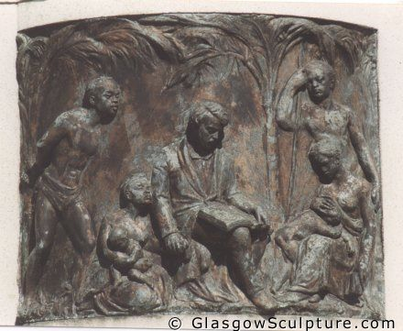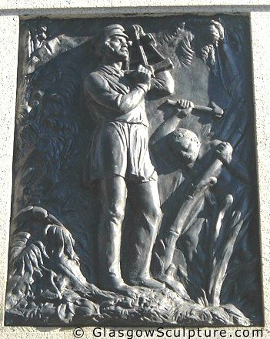

These images that are a part of the David Livingstone statue perfectly illustrate Scotland’s longstanding view of its involvement in slavery, which only in the last few years has been challenged. After the passing of the Emancipation Act in 1834 Scotland soon fashioned themselves champions of the enslaved, the vanguard of the abolitionist movement. In 1883 a statement from a once strongly anti-abolitionist organization the Glasgow West Indies Association reads;

It is to Glasgow’s lasting honour that while Bristol and Liverpool were up to their elbows in the slave trade, Glasgow kept out of it. The reproach can never be levelled at our city as it was Liverpool that there was not a stone in her streets that was not cemented with the blood of a slave.

In a span of 50 years they had seemingly forgotten Scotland’s significant role in the trans-Atlantic slave trade. It is from this Scotland as abolitionist movement that this statue is born. Livingston is depicted as the saviour of enslaved Africans, surrounded by grateful persons while spreading Christianity. The Africans themselves are stereotypically depicted as scantily clad, pitiful or doing strenuous work.

I do not seek to diminish Livingstone or Scotland’s role in the abolition of slavery however, it is important to understand that that is not the whole story or where the story even begins, but rather an attempt of a nation to build an identity, one that is not linked to the atrocities of the slave trade.

Glasgow Cathedral
Inside we will find dedications to Alexander Speirs of Elderslie (1714-82; 68), Sir James Stirling of Keir (1740-1805; 65) and Andrew Cochruane (died age 86 in 1777) and also the burial plot of the Oswald Family.

The burial plot of the man to whom Buchanan Street is dedicated, Andrew Buchanan (1725-83; 58), the nephew of Buchanan of Drumpellier, founder of the Virginia dynasty is located outside the Cathedral.

- Andrew Buchanan (1725-83; 58)
- Buchanan Street - This was arguably the most Potent symbol of modern Glasgow's image as a cosmopolitan city is named after the tobacco Lord Andrew Buchanan. The Buchanans had considerable wealth and social status in the 18th century Glasgow, and Andrew was a leading partner in both Buchanan, Hastie and Co and Andrew Buchanan and Co, for a time one of the most powerful Virginia trading firms, although they folded in 1777 due to financial difficulties brought on by the American War of Independence, 1775-83.
- Andrew Buchanan purchase the land now known as be Buchanan Street in 1760, and lived there for a number of years. The latest sold of some of the land around his property. The first tournament in the area was built in 1774. It is ironic that a street originally sold of as small value plots due to it's distance westward from the business centre of town which was originally at Trongate, arguably the wealthiest Street in Glasgow.
His father Andrew Buchanan of Drumpellier began to lay out a new street called Virginia Street in 1753 although he died before his son George Buchanan of Mount Vernon 1728-62 built the opulent Mansion

- Alexander Speirs of Elderslie (1714-82;68)
- He was one of the original Tobacco Lords and also known to some as 'the mercantile god of Glasgow'.
- Married Mary Buchanan in 1755 and became a leading partner in the Buchanan family interests.
- Was originally from Edinburgh, and his story illustrates the kinship networks and connections crucial for colonial trading success.
- Purchased Virginia Mansion in 1770 and unlike his colleagues he died with his fortune still intact.

- Sir James Stirling of Keir (1740-1805;65)
Owned plantations and enslaved people in Jamaica.

- Sir James was the head of The Stirling family owned the Keir and Cawder estates near Glasgow and bought plantations in Jamaica in the mid 18th century.
- He had 22 children, many of whom migrated to the Caribbean as merchants, the family’s connection to Jamaican plantations and slavery lasted till 1850.
Notes:
Stirlings of Keir

James Stirling of Keir and Cadder (1693-1749) lost his estates in 1715 after being accused of plotting to help the Stuart family invade Britain (the family eventually regained the land). He had twenty-two children and little means to support them, thus a number of his sons (which there were fourteen) set out to the West Indies to make their fortune. They settled in Jamaica and started out as bookkeepers, merchants, and worked their way up to plantation overseers and finally purchased their own sugar plantations called Hampden and Frontier Estate. The estates were owned by the family till the 1850s when they went into decline and were sold.

The Stirlings were not absentee planters but were actively involved in the day-to-day running of the plantations. A letter from July 8th 1766 written by James Stirling to his brother Archibald in Scotland details life in Jamaica, a slave revolt that threatened to destroy Hampden and the massive earthquake that hit the region. All in all he came to the conclusions that the West Indies did not agree with him and left the island a year later.

List of supplies to be sent from Scotland to the estates in Jamaica:

Stirling of Keir Stained Glass:

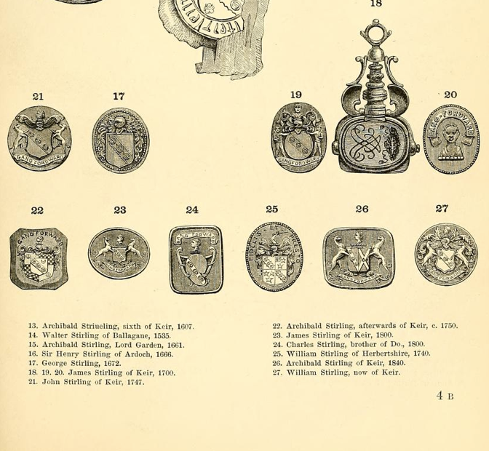
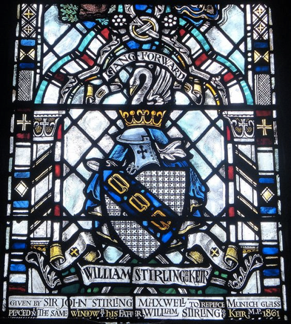
- It is interesting that the crest featured on the Cathedral window donated by the Stirlings is different from the variations that existed in the family from the last 150 years. The Moor’s or Negro’s head usually forms the crest of the armorial bearing of the family of Keir, however the ancient Cadder crest has been used on the window although William Stirling’s seal features the Moor’s head. Furthermore, William Stirling and consequent members of the family have ‘orientalised’ the Moor’s head moving away from more typical ‘African’ features. This is a deliberate attempt to distance themselves from their slave- owning past, especially as this crest was issued at the height o the family’s involvement in Jamaican plantations.

- Andrew Cochrane (lived till age of 86 dying in 1777) – no need to look at stained glass just mention.
A Virginia Don, who was the Lord Provost of Glasgow 6 times, and the owner of the King Street Sugarhouse.

- Oswald Family – Treaty of Paris - Image
Family plot is to be found in the nave under the slabs marked 'G.O.' main family Richard Oswald (1687-1763); Alexander Oswald (1694-1766) from Caithness

Richard Oswald of Auchincruive (1705-84; 79), nephew of a main family, was actually buried at St Quivox Parish church in Ayrshire. He ran his own showing voyages mostly to Charleston, South Carolina to meet the demand for labour on rice plantations; during his 36 year period an estimated 13000 captured Africans were transported to the so called 'new world' and forced into chattel slavery.
- Colonial representative responsible for trade in the Caribbean and Virginia till 1741 when he returned to Glasgow as junior partner in firm
- Moved to London in 1743 to set up his own business empire - Grant, Sargent and Oswald trading in tobacco, sugar, horses and enslaved people.
- 4 Plantations, Caribbean and 30,000 acres in East Florida
- In 1748, along with 4 other London-based Scots, purchased Bance Island on the rice coast of West Africa more precisely an island in the Sierra Leone river
- Diplomat at the Treaty of Paris which concluded the American War of Independence in 1783. He died a year late with a fortune £500,000 (today £5million)

Tontine Heads – Provand’s Lordship – Castle Street
The famous Tontine heads were located above ten arches on the Tontine, and can today be found in the gardens of the Provand’s Lordship. On our way to the City Halls we will pass near The Trongate which was named after the old public weigh-beam or ‘tron’, also one of the original eight streets of Glasgow before the 18th century expansion. The modern day Trongate was the location of the Tontine Rooms, the Tontine Society of Glasgow was established in 1782, and was the forerunner for the later Royal Exchange. Original subscribers included prominent Glasgow merchants such as:
- John Glassford (1715-83)
- George Bogle of Daldowie (1700-84)
Styled as the social and commercial headquarters of Glasgow, it included a hotel, coffee room and assembly hall. It was said that the Tobacco Lords strolled around the Tontine Piazza, in their scarlet cloaks and gold tipped canes, citizens of lesser standing moved out of their way. It is important to say that the scale of new wealth in Glasgow was unprecedented and it created a new breed of aristocracy. The Virginia Dons had dominated the public and private domain of the city for 100 years after 1700 when tobacco was established as the most important export from the american colonies and Glasgow was the main marketplace.
The impact of the new found wealth of merchant families such as the Bogles, Buchanans, Dunlops, Oswalds and Ritches had a profound impact on the urban environment as the rapid influx of colonial wealth prompted conspicuous consumption.

What do they represent? We don't know, however they are not supposed to be a depiction of the merchants.

Provand’s Lordship
- Tontine heads: although the inspiration for the Tontine Heads are not known, two of them display characteristics associated with tobacco. On 18th century tobacco trading cards and maps of the Americans, Native Americans were often stereotypically depicted wearing feathered headdress and tobacco leaves. These images became synonymous with tobacco. As tobacco served as the biggest source of revenue for most of the Glaswegian merchants it is not surprising that the crop be referenced in the architecture of their meeting place.

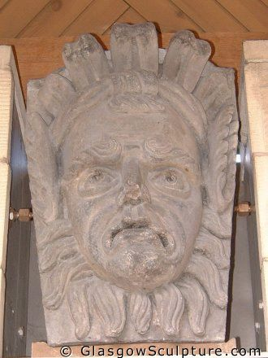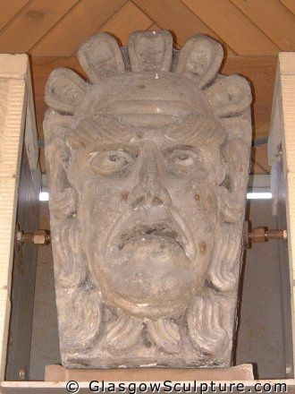

Tontine Rooms
- Tontine Society: a tontine is a method of investment, in which each member puts in an agreed upon amount and is paid dividends in a specified amount of time. In this particular variation of the tontine, the last surviving member of the group is awarded all the capital and the tontine is ended.
- The last survivor of the Glasgow Tontine was Cecilia Douglas of Orbiston, who inherited Mount Pleasant Estate in St. Vincent from her husband Gilbert Douglas and received £6027 of slave compensation. Cecilia’s name has come up recently because she donated 13 old Master paintings to the now Glasgow Museums, ostensibly bought by gains from slavery. However, most of the art collections amassed in the region were done so by money gained from slave-produced goods. For example at Keir House the Stirlings housed 112 old master oil paintings.
Cecilia Douglas - inherited the finances of the Tontine Society. Insert more info.

Old College - Glasgow University, High Street
This was the original site of the predecessor of Glasgow University – Old College, back when High street was the heart of the city. Founded in 1451 by papal bull, its location helped foster strong relationships with commerce and merchants. This institution of learning was closely aligned to the Cathedral we just visited as the Bishops Archbishop of Glasgow controlled both institutions.
It relocated in the 19th century to its current location in the West-end. By 1800 Scotland had 6 universities compared to 2 in England. It has been estimated that this country had more places in higher education per head of population by 1800 than any other country in Europe.
- Dr Stephen Mullen tells us that many of the sons of the Tobacco Lords matriculated before embarking on the ‘Grand Tour’ through Europe. (pg51 – It Wisnae Us)
- A recent book by the notable historian Sir Tom Devine – Recovering Scotland’s Slavery Past in the opening chapter he highlights the links of between the education system, emigration and sources of employment with social mobility.
In the preceding centuries the teaching system had evolved from a dependency in philosophy, classical languages and theology to include a focus on law, medicine, history and science. He states that there was large scale intellectual migration to all parts of the Empire, estimating that between 1680 and 1780 graduates of three largest Scottish universities (Aberdeen, Edinburgh and Glasgow) accounted for a third of Western Europeans who went to the American colonies. Another note states that from 1750 – 1850, 10000 medical graduates from Scottish universities, of which only a minority could be employed in the UK.
Another important connection we must consider is that Glasgow University also contributed to the spread of enlightened thought; in fact during the age of the Tobacco Lords it was also synonymous with the abolition movement in Scotland which in turn inspired campaigners globally.

Frances Hutcheson (1694-1746) was born in Ulster and descendant of Scottish emigrants. Attended the university 1710-1718, and was appointed Chair of Moral Philosophy in 1730. He has been referred to by many as the ‘founding father of the enlightenment’. His most influential work, A System of Moral Philosophy’ in which he posits:
- This state of natural liberty obtains among those who have no common superior or magistrate, and are only subject to God, and the law of nature’
- He also criticizes contemporary justification of chattel slavery which treated enslaved people as inherited property, a state which was passed on to progeny for generations. He states: ‘no damage done or crime committed can change a rational creature into a piece of goods void of all right, and incapable of acquiring any, or receiving any injury from the proprietor.’
Adam Smith (1723-90) attacked slavery as the vilest of all states.
In June 1788, one of the first anti-slavery petitions from west of Scotland was presented by the university.
It also played an important role to the realization of emancipation as demonstrated by the career of James McCune Smith (1813-65) who was the first African American to graduate as Medical Doctor in the world and also the first to practice medicine in the USA.
James McCune Smith – member of The Glasgow Emancipation Society campaigning for universal emancipation, it helped fund his education. More information.
Botany – Alexander Anderson
Arrow Root – medicinal uses
Breadfruit
Quinine

Trongate
It was here that the early merchants in Glasgow had their commercial headquarters; this was the area from which they could look out for merchants awaiting their cargoes from Virginia and the Caribbean. The goods were weighed at the Tollbooth on their way to the merchant’s warehouses. Cargoes would then be transported to England and Europe, in particular France.

City Halls, Albion Street (George Murray 1841)
The first performance venue in Glasgow, it was a focus for events ranging from orchestral concerts to political rallies and anti-slavery meetings.

Frederick Douglass (1818-95) an African American, escaped from slavery in Maryland in 1838 to become a leading campaigner. Following lecture tours in the USA, Douglass spent two years on a circuit of churches and chapels throughout Britain and Ireland till 1848.

Another example, of Glasgow’s involvement in the campaign for universal emancipation, The Glasgow Emancipation Society started the Uncle Tom Offering in honour of royalties to Harriet Beecher Stowe, when she could not receive in Britain.

During her UK tour, she was a guest of the Glasgow Female New Association for the Abolition of Slavery. This society also hired a series of African American abolitionist lecturers.

In 1877, the real-life inspiration for the fictitious character of Uncle Tom was given a civic reception in the city halls. Rev. Josiah Henson who had escaped enslavement in 1830 and travelled to Canada he died at the age of 94 in 1883.

Ramshorn Kirk and Graveyard, Ingram Street (Thomas Rickman, 1820)
St David’s Church at no 98 Ingram Street now the Ramshorn Theatre is an early example of Gothic Architecture revival. The old Ramshorn cemetery is now partly covered by Ingram Street was regarded as the fashionable and expensive place to be buried in 18th century Glasgow.

A number of prominent merchants were buried there including 2 tobacco lords:

John Glassford (1715-83) – son of a magistrate and former merchant from Paisley
- He became the wealthiest OF THE TOBACCO LORDS
- He bought an estate of 33 acres from The Merchants House in 1745 – we will see the Merchants House later in this tour.
- On this land he built a mansion which he named Whitehill – this area is now known as Duke Street in the southern part of Dennistoun.
- He later bought the land surrounding his estate in order to increase it value, attractiveness and lay a carriageway for his daily commute westwards to the commercial centre of Glasgow which we now know that during his era it was the Tontine Rooms, The Trongate and High street.
- He sold Whitehill House in 1759 and purchased Shawfield Mansion in 1760. He viewed himself as a ‘gentleman improver’. (Stephen Mullen states in his book that wealth gained from trades with the New World had a marked effect on land development in the West of Scotland). Between 1770 and 1815 approximately half of the 140 merchants in Glasgow involved in the tobacco and sugar trade owned landed estates of over 500 acres. They purchased estates in Glasgow, Renfrewshire, Dunbartonshire, Lanarkshire, Stirlingshire and Ayrshire.

Ramshorn Kirk
- It is apt that this location marks the burial of not only the Foulis Brothers but also Andrew Buchanan and John Glassford, both Tobacco Lords who funded the Foulis’ Academy of Arts (1753). A core tenant of the Scottish Enlightenment was civic duty as mark of a gentleman and person quality and taste. It is a theme we see time and again in the lives of Glaswegian merchants, putting at odds their use of slave labour with their strong sense of morality and duty. The Fine Art Academy is born out this civic duty and betterment of the city, which helped spark Scotland’s fine art movement. Previously, the wealthy Scottish had lured foreign artist to Scotland, but here we have the training of local artist funded by West Indian merchants.

- The Glassford portrait that has become the ‘face’ of the new Scotland and slavery movement was painted by Archibald McLauchlan circa 1767, a pupil at the very Academy partially funded by Glassford. The painting depicts John Glassford’s family and a slave boy in the corner. The image of the slave has only been ‘rediscovered’ in the last few years when the painting was cleaned as it was allowed to darken fade from memory. A fierce debate about whether this ‘fading’ was an intentional attempt to hide Scotland’s slave past.

- John Glassford was a partner in a merchant shipping firm, owned estates in Virginia and Maryland and numerous stores in the American colonies especially along the Rappahannock River, Virginia. The Library of Congress houses hundreds of the cashbooks, journals and ledgers of these stores which give a detail picture of how business was conducted by Scottish merchants in America. It is not surprising that most of these stores were managed by young Scottish men usually under apprenticeship with the Tobacco Lords. This very tight-knit method of business is also illustrated in the marriages of Scottish merchants, as they usually married into families with which they had business holdings. For example, John Glassford’s sister Rebecca married Archibald Ingram, his business partner and funder of the Foulis’ Academy of Fine Art.

- Glassford bought the Shawfield Mansion that had been owned by Daniel Campbell who was a local MP. The Mansion had been the sight of a riot in 1725, when Campbell had aided in the addition of a second malt tax. The populace stormed the mansion and gutted the interior.

Andrew Buchanan of Drumpellier (1690-1759) – was one of the founders of Ship’s Bank, the first bank in Glasgow.
- Was one of the original Virginia Dons and was twice Lord Provost of the city.
- Virginia Street and the Virginia Mansion which was situated on the site of the modern Corinthian in Ingram Street were a testament to the wealth and influence of successive generations of the same Glasgow merchant family.
- By 1730 Andrew Buchanan and his two younger brothers had established the Firm Andrew Buchanan, brothers and Co which was the largest tobacco importers in Glasgow. Both the tobacco trade and the West Indian sugar trade in which the family also had interests depended on slave labour.
- Andrew was appointed Lord Provost twice in 1740-42 and was one of the consortium of merchants which founded The Shipbank, one of Glasgow’s first banks in 1750.
- Buchanan Society - more info

Other notables:
Robert (1707-76) and Andrew Foulis (1712-75) – who were leading booksellers, printers and publishers during the age of Enlightenment or as local Glaswegians called it at the time the ‘Age of Improvement’.
- Buried in Kirk Graveyard and remained interred when Ingram street widened. A cross marked RF and AF marks the spot where they were buried under modern pavement.
- They were appointed printers to the university in 1743 for classical works and class texts.
- Foulis Press in Glasgow printed the work of Frances Hutcheson n 1755, nine years after his death.
- Both born in Glasgow and attending the University, Robert studied moral philosophy under influence of Hutcheson.
- They later established the Academy of Fine Arts was supported by Glasgow University and financially supported by the Tobacco Lords John Glassford and Archibald Ingram

City Chambers designed by William young in 1890
The city Chambers is one of the most impressive buildings in Scotland. Completed in 1890 its grandeur reflects what was then the most powerful Empire in the world. Great Britain's economic development was built on trade with her colonies and this is dramatically portrayed in the chamber’s architecture.
On the topmost triangle on the main facade a statue of Queen Victoria is flanked by native peoples bringing gifts from the empire. It is a striking symbol of Victorian Glasgow's claim to be the second city of the Empire.
Yet like other major ports on the Atlantic seaboard such as Bristol and Liverpool, much of the city’s early wealth was built on a global trade which ran on slave labour.
By contrast Glasgow's position as a lead an abolitionist city is symbolised by the statue of James Oswald 1785 to 1853 in George Square. Oswald, who came from the merchant family which had been deeply involved in the tobacco and sugar trade since the 1730s, served as a Glasgow MP from the time of the 1832 Reform Act.
In 1836 he supported the petition of 30000 residents of the city to end the apprenticeship scheme in the West Indies that had continued a form of slavery after its formal abolition by Parliament in 1834.

Tobacco Merchant's House 42 Miller Street designed by John Craig in 1775
This house is the oldest surviving house in the merchant City. Miller Street was named after John Miller of Westerton a land speculator who first laid out the street plot in the 1750s. A variety of merchants built townhouses there.

Plot No. 6 was acquired by Mr Robert Hastie, who was described as an 'extensive American merchant', on the 6th of May 1772. After Hastie’s Firm - Robert and William Hastie - failed like so many others in the 1770s the land was sold to John Craig a wright (a maker or builder).

Number 42 was subsequently occupied by other prominent merchants such as Robert Findlay of Easterhill a tobacco importer who live there from 1780 until 1802 when he died.

The only one of its kind to survive, the house, a small scale interpretation of the mansions designed by Andrea Palladio in Italy’s Veneto region, illustrate the 18th century living conditions of average merchants sometimes called tobacco lairds in contrast with the grandeur Palladian homes of the much wealthier tobacco Lords. The building was restored as officers by Glasgow building Preservation Trust in 1995.

Merchants house, 7 West George Street designed by John Burnett in 1874
An Impressive monument to Glasgow's global trading. An organisation of Glasgow merchants established in the 17th century. In Glasgow's 'Golden Age of tobacco' it was central to the development of the city's commerce across the world. It was behind the deepening of the River Clyde to allow large shipping vessels to talk and it helped recruit troops during the American War of Independence to protect the tobacco trade.

The Globe, with a sailing ship, flanked by two female figures, which adorns the top storey of the building, was copied from the original Merchant's Steeple (1665) near the Trongate.

In the Trongate, Glasgow merchants waited and make a battleship to return which explains the Merchant's House motto engraved in stone which translates to ‘so often returning to the same place’. On the walls are carvings of Neptune, and ornate compass drawing, with the Glasgow coat of arms all helping to reinforce the historic role of Glasgow is the second city of the world's most powerful Empire.

Dr Michael Morris will give a talk of George square statues.

Cunninghame mansion

The Cunningham Mansions now the core of the Gallery of Modern Art, in Royal Exchange Square, was built for William Cunninghame of Lainshaw who died in 1789.

He was one of Glasgow's most prominent 18th century Mansions. Cunningham had interest in both of the Virginia tobacco trade and the West Indies sugar trade. Both of these trades were built entirely on slave labour.

Cunningham purchased three plots in what is now known as Queen Street but was then Cow Loan, a country track. He spent £10,000 a huge sum on his Townhouse described as one of the most splendid houses in the West of Scotland, it stood in stark contrast to the semi rural conditions that prevailed close to the centre of Glasgow. Cunningham had the motto etched on the mansion, which translates as 'I emerge' - a boast of his own rapid rise in Society.

Cunningham had significant interests in both the Virginia tobacco trade and the West Indies sugar trade. He owned the Grandvale plantation in Westmoreland, Jamaica, which had 300 slaves. Along with George Buchanan, Robert Bogle of Daldowie and John Glassford, William Cunningham of Lainshaw formed The Tontine Society of Glasgow. As previously mentioned the Tontine Society raised funds of between 5000 and 6000 pounds to build the Tontine rooms.

Since 1829, the mansion, much altered by the architect David Hamilton sometimes known as the father of Glasgow's architecture took on a new lease of life as the Royal Exchange. it fast became the centre of commercial life in Glasgow, trading in commodities such as coal, iron, cotton, sugar and chemicals. In 1996 the building entered the third major phase of its history as the Gallery of Modern Art.
William Cunninghame

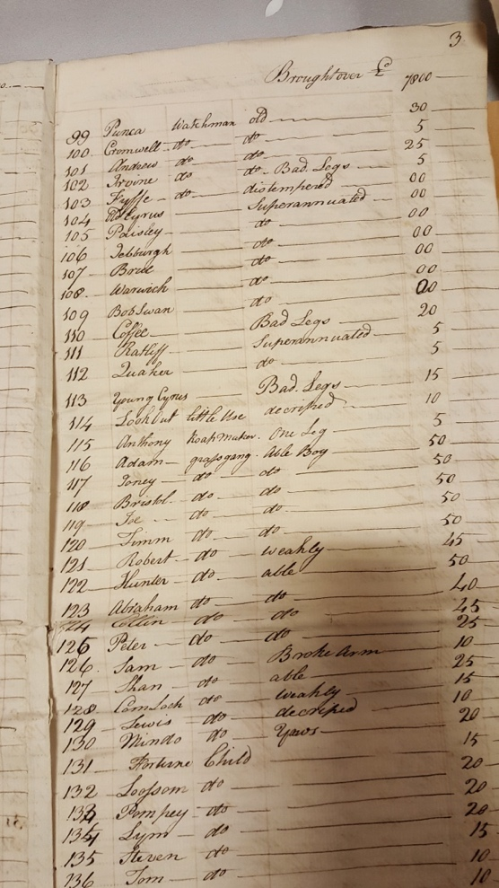
- Owned sugar plantation Grand Vale Estate in Westmoreland, Jamaica. If there is any doubt where the £10,000 came from to build Cunninghame’s Mansion, this list of 296 slaves should be an indication. The list which was done as part of an inventory of the estate in 1773 valued the alone at £15,170 and the entire estate at £40510. The slaves alone were worth more than the Cunninghame Mansion.

- Letters from John Cunninghame to the Grand Vale Estate manager Taylor Cathcart dated 1812 also illustrate the change in management of slaves on the plantations. As a result of the Abolition of the Slave Trade in 1805, estates became more concerned with birth and death rates of their slaves, as reproduction was the main source replenishing slave labour. This concern is illustrated in the following letter: Dear Taylor, I had the pleasure or receiving yours accompanied by a list of Negroes stock on Grand Vale. I am happy to observe that the increase of Births is likely to keep pace with the decrease accompanied by the deaths of the old and infirm people and I am also much pleased to see that you are resolved to afford every comfort to the women in a state of pregnancy. Indeed I suppose you will always be disposed to do everything in your power for the comfort of all slaves, it will be a very satisfactory and consolatory reflection to you after you have relinquished the management…”

Compensation Records
Archibald Stirling of Keir: £12,517
Charles/ William Stirling of Kippendavie: £15,613
William Cunninghame: £ 3,278
John Campbell Sen. & Co.: £81,017
Oswald family: £5,445

